Supplementary Information
Open-Source Machine-Learning Framework for Predicting PD-L1 Inhibitory Potency Using Curated Bioactivity Data and Molecular Fingerprints
Monsin Sangsawatª, Bunthita Watpuangª, Tonkla Nathapinthuª, Phuripat Srisirirojª, Nonthaneth Nalinratana^{a,b}, Pasrawin Taechawattananant^{c}, Worathat Thitikornpong^{a,d} and Pornchai Rojsitthisak ^{a,d,*}

ª Center of Excellence in Natural Products for Ageing and Chronic Diseases, Chulalongkorn University, Bangkok 10330, Thailand
^{b} Department of Pharmacology and Physiology, Faculty of Pharmaceutical Sciences, Chulalongkorn University, Bangkok 10330, Thailand
^{c} Department of Department of Biochemistry and Microbiology, Faculty of Pharmaceutical Sciences, Chulalongkorn University, Bangkok 10330, Thailand
^{d} Department of Food and Pharmaceutical Chemistry, Faculty of Pharmaceutical Sciences, Chulalongkorn University, Bangkok 10330, Thailand

*Corresponding author
Pornchai Rojsitthisak
Department of Food and Pharmaceutical Chemistry, Faculty of Pharmaceutical Sciences,
Chulalongkorn University
Email: pornchai.r@chula.ac.th

List of Figures
Figure S1 Data collection acquired from ChEMBL 3
Figure S2 Data Filtering Workflow for Curating Bioactivity Records 4
Figure S3 Cell-based assay selection 4
Figure S4 RDKit descriptor generation 5
Figure S5 Pearson Correlation Heatmap of the Final Selected Molecular Descriptors (RFE-CV Method) 8
Figure S6 Pairwise Scatter and Density Plots of the Six Descriptors Most Strongly Correlated with pIC₅₀ 9
Figure S7 Outlier removal 10
Figure S8 Fingerprint generation 10
Figure S9 Workflow for Stratified Data Splitting and Random Forest Model Training Using MACCS and Morgan Fingerprints 11
Figure S10 Data Cleaning and Descriptor Calculation Pipeline for BindingDB PD-L1 Compounds 12
Figure S11 Workflow for Generating Fingerprint Representations and Predicting BindingDB Activities Using the Trained Random Forest Model 13

List of Tables
Table S1 Model Training Result (Random Forest regression) 14
Table S2 Model Training Result (Kras Regression) 15
Table S3 Model Training Result (Gradient Boost Regression) 16
Table S4 Model Training Result (XG Boost Regression) 17

- Dataset Collection and Curation
The data input process was retrieved directly from the ChEMBL website and managed using a metanode template. The data acquisition process followed the reference template provided on the KNIME website, TeachOpenCADD_Workflow1_Data_acquisition_ ChEMBL (Workflow 1 step 1).
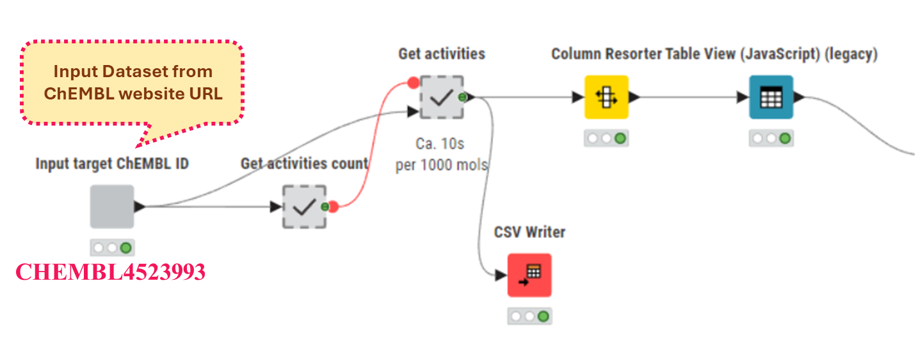
Figure S1 Data collection acquired from ChEMBL
Data were filtered to include only records containing IC₅₀ values, SMILES, and assay information, with exact measurements (excluding entries with “> or <”) and units reported in nM. Data 4078 records were filtered in for the next step (Workflow 1 step 2-5).
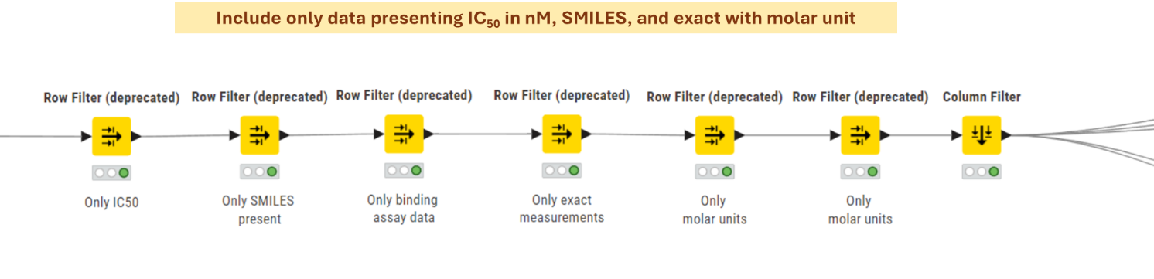
Figure S2 Data Filtering Workflow for Curating Bioactivity Records
The dataset contains descriptions of various binding assays. For model training, data obtained from Alpha assay and HTRF were selected due to their high prevalence and experimental reliability. In cases where duplicate records appeared in both Alpha assay and HTRF datasets, the Alpha assay data were given priority for inclusion (Figure 3).
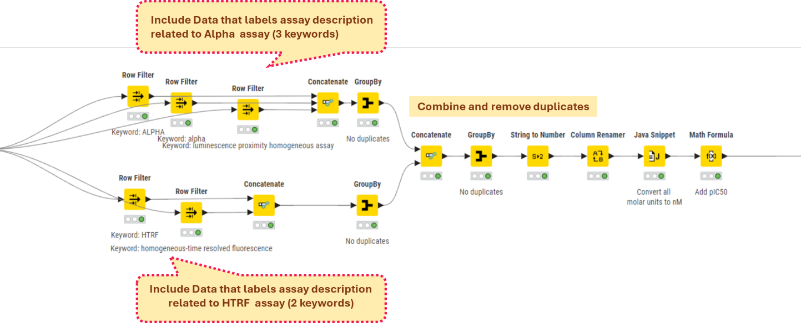
Figure S3 Cell-based assay selection
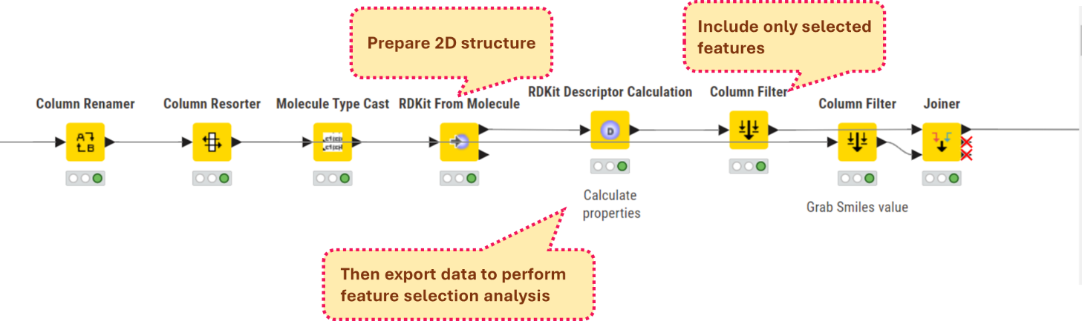
Figure S4 RDKit descriptor generation
Supplementary Code: Feature Selection Pipeline for pIC₅₀ Prediction
Descriptor matrices were first restricted to numeric columns and rows, with missing pIC₅₀ values being removed. Remaining missing descriptor values were imputed using the median, followed by variance filtering (VarianceThreshold, threshold = 0.1) to discard near-constant features. Highly intercorrelated descriptors (|r| > 0.7) were then eliminated based on the upper triangle of the Pearson correlation matrix. Features showing meaningful association with pIC₅₀ (|r| > 0.1) were retained, and a Random Forest–based Recursive Feature Elimination (RFE) was finally applied (up to 12 features) to identify the most informative subset, which was exported as selected_features.csv for subsequent modeling.
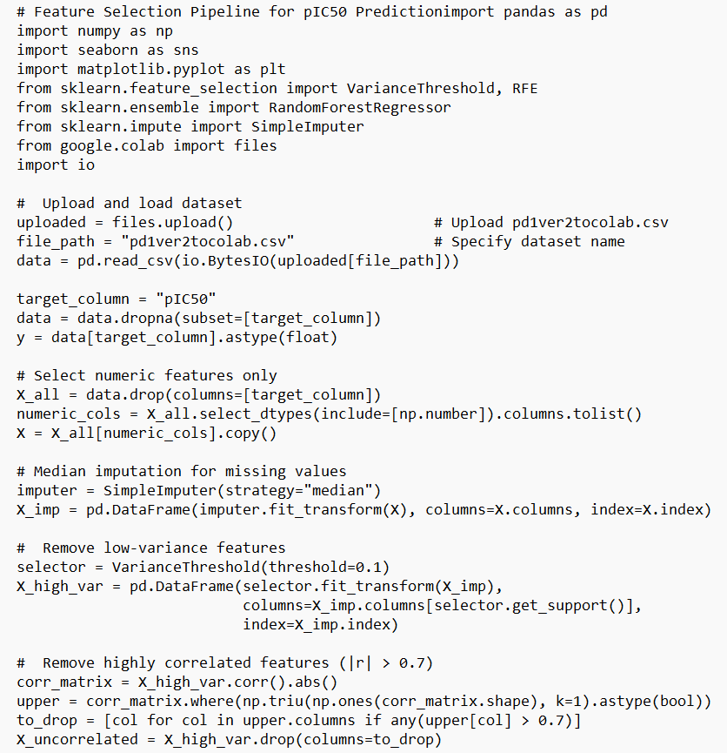
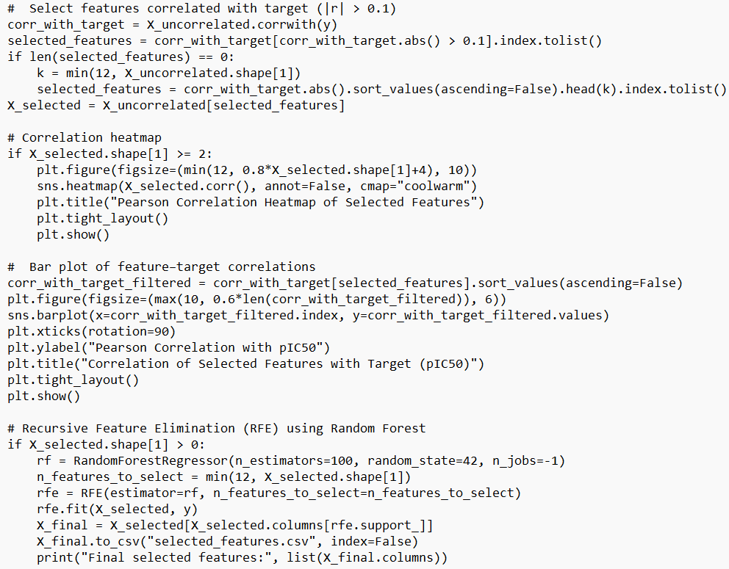
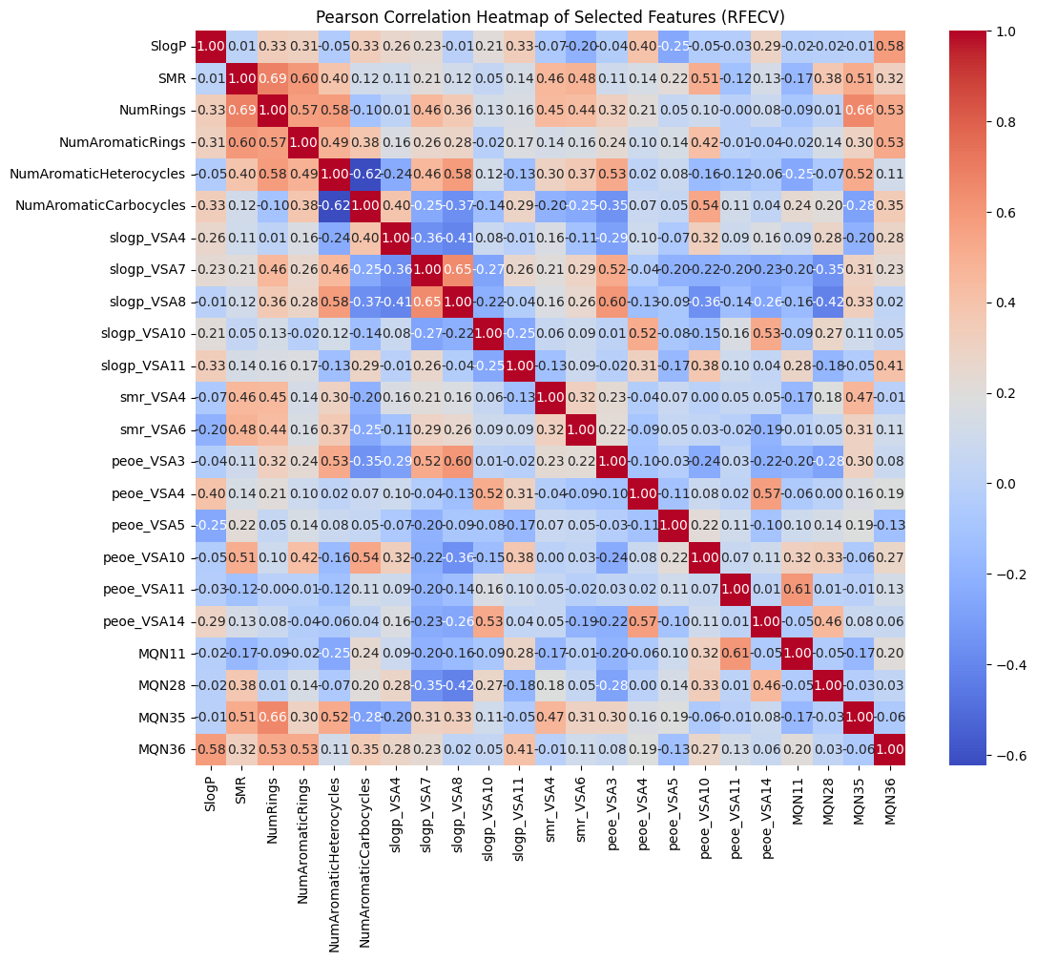
Figure S5 Pearson Correlation Heatmap of the Final Selected Molecular Descriptors (RFE-CV Method)
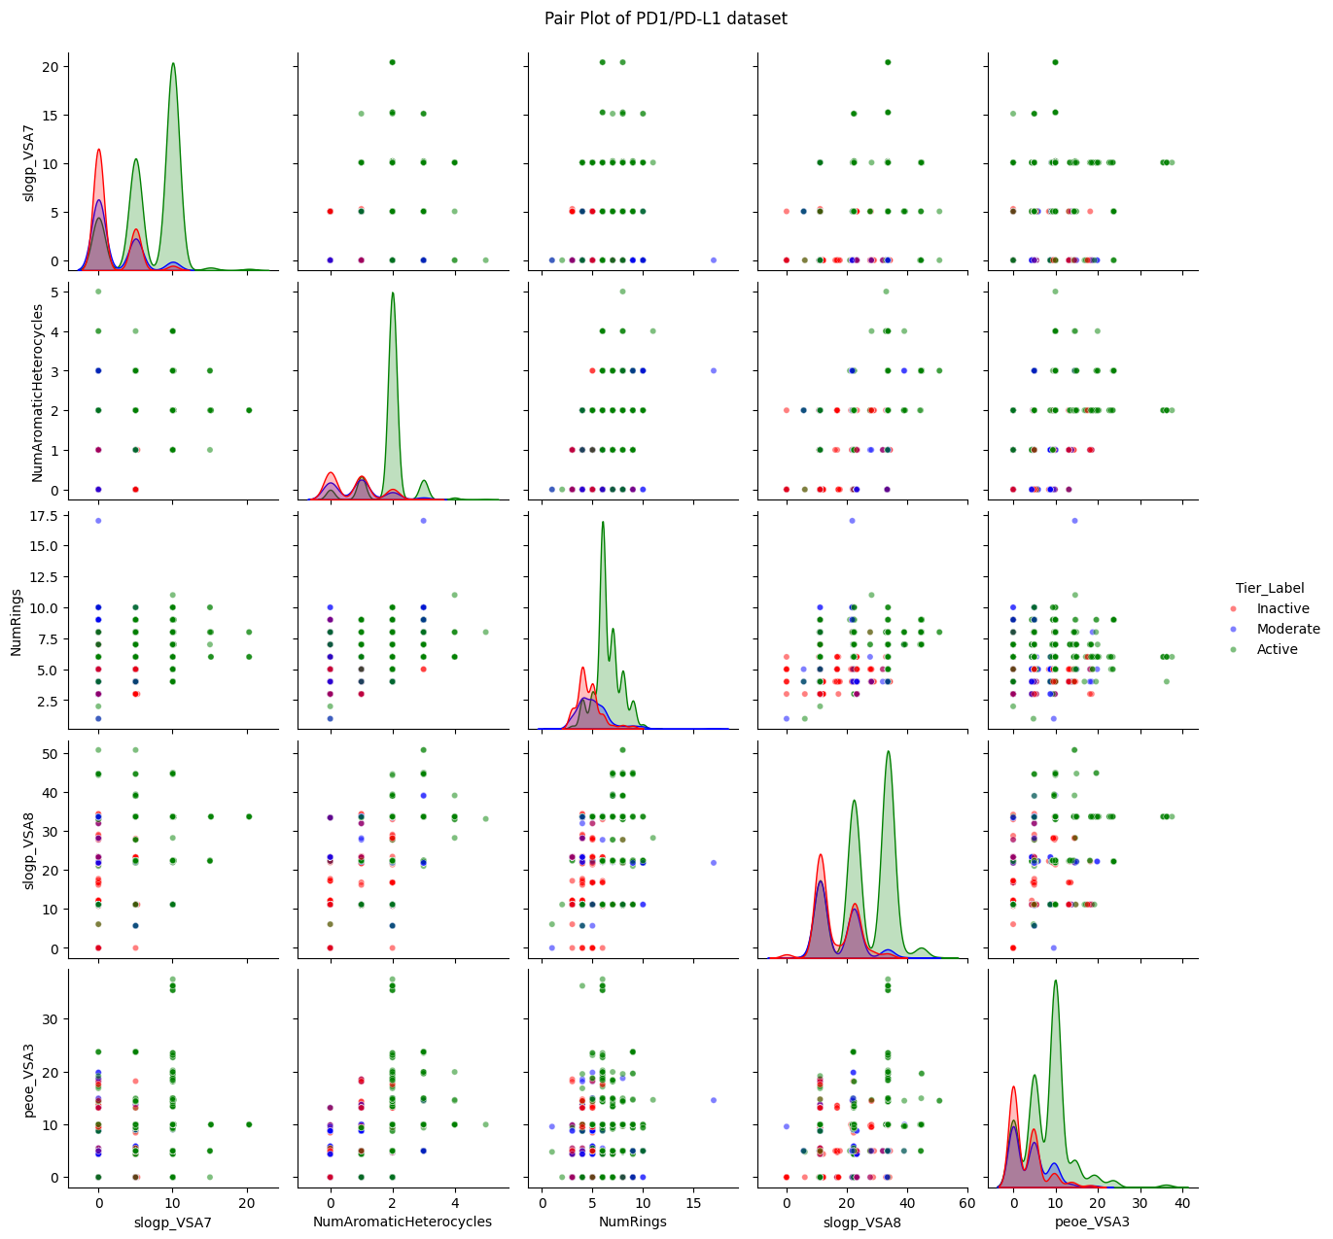
Figure S6 Pairwise Scatter and Density Plots of the Six Descriptors Most Strongly Correlated with pIC₅₀

Outliers were identified and removed using the modified Z-score method.
An observation was considered a potential outlier if its absolute modified Z-score (mzᵢ) exceeded 3.5 median absolute deviations (MAD) from the median, i.e., when:
$$∣MZ_{i}∣=∣\frac{0.6745×(x_{i}-\tilde{x})}{MAD}∣>3.5$$
where $\tilde{x}$ is the median of the dataset and
$$MAD=\text{median} (∣x_{i}-\tilde{x}∣)$$
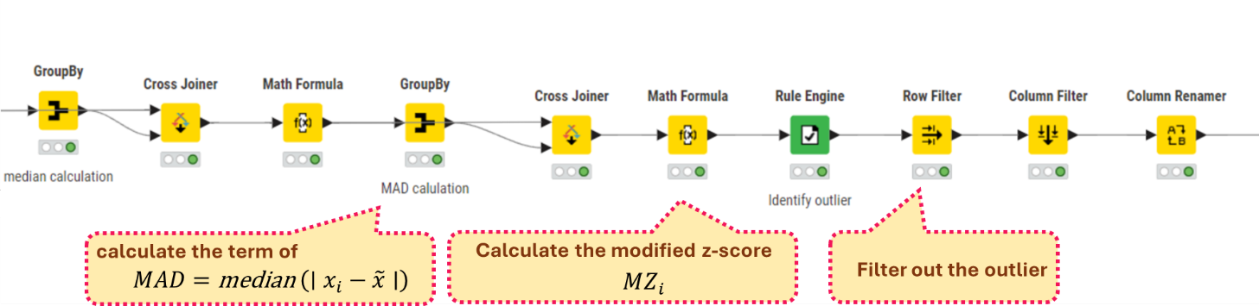
Figure S7 Outlier removal
The final curated dataset contained 2,413 unique compounds. Molecular fingerprint descriptors, including MACCS keys (166-bit) and Morgan circular fingerprints (radius = 2, 1,024-bit), were generated. The resulting data were then combined and subsequently partitioned for the model training process.
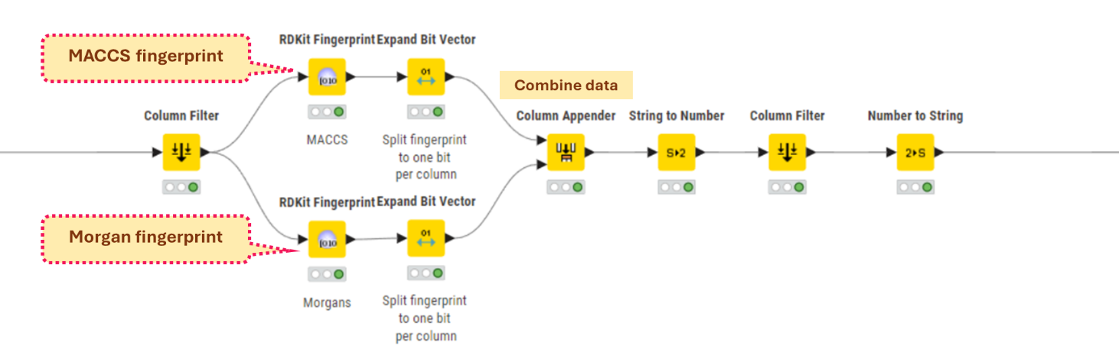
Figure S8 Fingerprint generation
After data partitioning, the pIC₅₀ values were removed from the feature matrix, and only the 23 selected molecular descriptors together with the fingerprint features were used as model inputs. Models were fitted on the training subset, while the test subset (15%) was used as an internal validation set for iterative hyperparameter tuning and model selection based on R², RMSE, and MAE. Once the best-performing configuration had been identified, its predictive performance was finally assessed on the independent external validation set (15%), which remained completely unused during model optimization. The resulting statistics from the training, internal test, and external validation subsets were retained for subsequent comparative analysis.
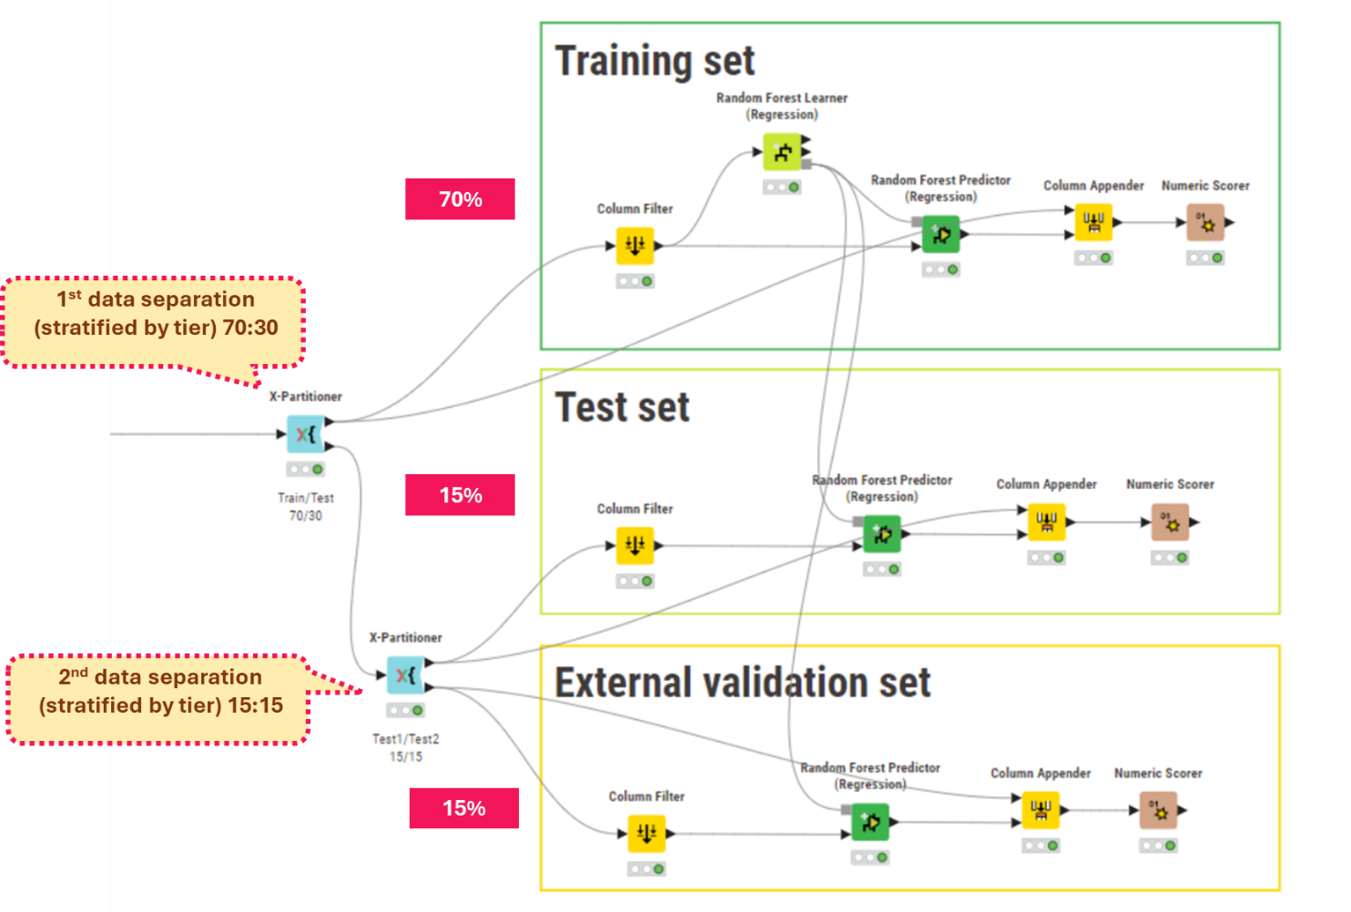
Figure S9 Workflow for Stratified Data Splitting and Random Forest Model Training Using MACCS and Morgan Fingerprints

- BindingDB Dataset Curation and Activity Prediction
The dataset was downloaded from the BindingDB website (https://www.bindingdb.org) using the keyword “PD-L1.” The SDF Reader node was used to import the retrieved bioactivity records into the workflow. Initial preprocessing included duplicate removal, structural standardization, and filtering out entries with missing or incomplete assay information. RDKit molecular objects were then generated, pIC₅₀ values were calculated, and molecular descriptors were computed. All compounds were subsequently checked for structural duplication against the curated ChEMBL dataset. The remaining unique BindingDB molecules were processed following the same curation protocol as the ChEMBL data, including fingerprint generation and prediction using the trained models.
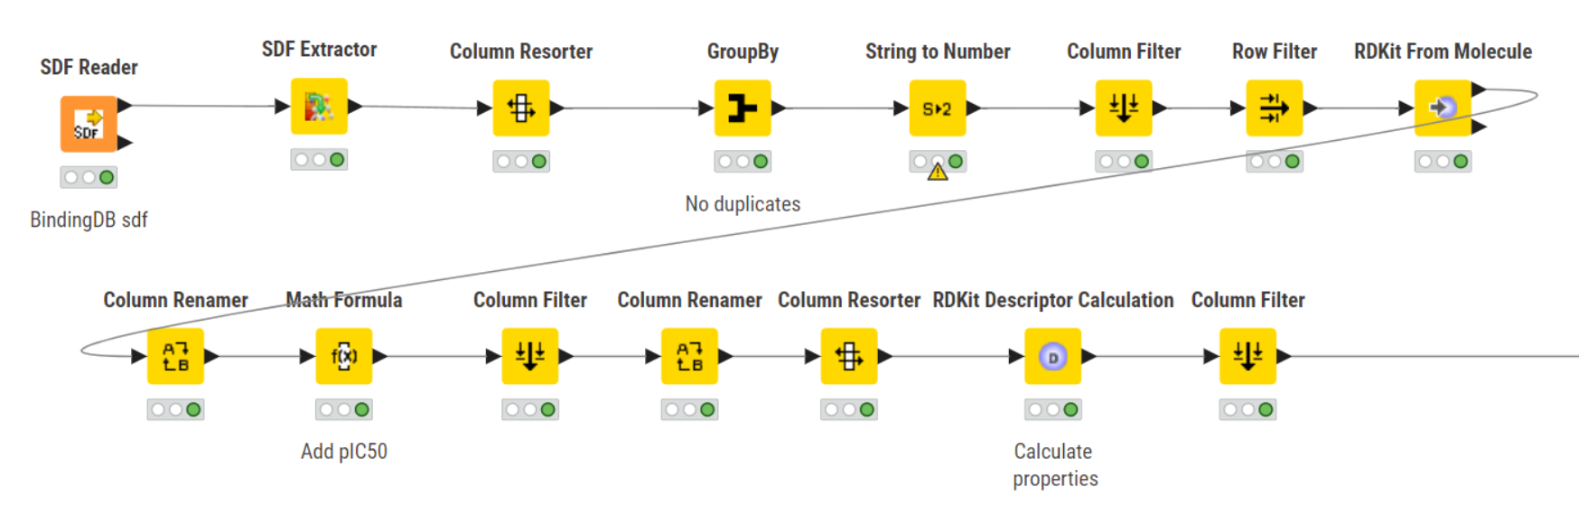
Figure S10 Data Cleaning and Descriptor Calculation Pipeline for BindingDB PD-L1 Compounds
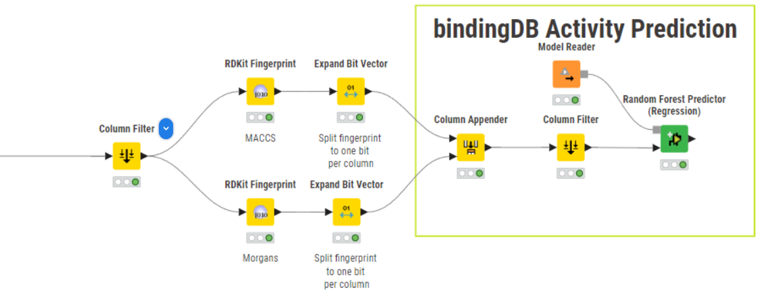
Figure S11 Workflow for Generating Fingerprint Representations and Predicting BindingDB Activities Using the Trained Random Forest Model
- ML Model Evaluation
Tables S1–S4 report the model evaluation metrics (R², MAE, MSE, RMSE, MSD, and MAPE) for three modeling configurations: (i) MACCS-only, (ii) Morgan-only, and (iii) a hybrid MACCS–Morgan fingerprint model. Each of these configurations was further combined with the selected molecular descriptors to generate the final feature sets used for model development. Model performance values are reported as mean ± standard deviation, calculated across four fixed random seeds.
Table S1 Model Training Result (Random Forest regression)
Dataset | R² |  |  | MAE |  |  | MSE |  |  | RMSE |  |  | MSD |  |  | MAPE
MACCS
Train set | 0.969 | ± | 0.002 | 0.191 | ± | 0.002 | 0.083 | ± | 0.003 | 0.289 | ± | 0.007 | 0.009 | ± | 0.001 | 0.026 | ± | 0.001
Test set | 0.858 | ± | 0.017 | 0.394 | ± | 0.025 | 0.372 | ± | 0.061 | 0.610 | ± | 0.049 | 0.011 | ± | 0.045 | 0.056 | ± | 0.006
External validation set | 0.848 | ± | 0.015 | 0.404 | ± | 0.010 | 0.404 | ± | 0.070 | 0.635 | ± | 0.055 | 0.052 | ± | 0.029 | 0.060 | ± | 0.004
Morgan
Train set | 0.973 | ± | 0.002 | 0.176 | ± | 0.001 | 0.072 | ± | 0.003 | 0.268 | ± | 0.005 | 0.010 | ± | 0.001 | 0.024 | ± | 0.001
Test set | 0.867 | ± | 0.015 | 0.380 | ± | 0.022 | 0.348 | ± | 0.058 | 0.589 | ± | 0.048 | 0.022 | ± | 0.036 | 0.054 | ± | 0.006
External validation set | 0.864 | ± | 0.015 | 0.380 | ± | 0.010 | 0.362 | ± | 0.067 | 0.602 | ± | 0.055 | 0.060 | ± | 0.020 | 0.056 | ± | 0.004
hybrid MACCS–Morgan
Train set | 0.975 | ± | 0.002 | 0.167 | ± | 0.001 | 0.066 | ± | 0.003 | 0.257 | ± | 0.006 | 0.011 | ± | 0.001 | 0.023 | ± | 0.001
Test set | 0.871 | ± | 0.015 | 0.372 | ± | 0.022 | 0.337 | ± | 0.058 | 0.581 | ± | 0.049 | 0.023 | ± | 0.038 | 0.053 | ± | 0.006
External validation set | 0.863 | ± | 0.014 | 0.378 | ± | 0.009 | 0.364 | ± | 0.065 | 0.604 | ± | 0.054 | 0.059 | ± | 0.021 | 0.056 | ± | 0.004

Table S2 Model Training Result (Kras Regression)
Dataset | R² |  |  | MAE |  |  | MSE |  |  | RMSE |  |  | MSD |  |  | MAPE
MACCS
Train set | 0.972 | ± | 0.007 | 0.195 | ± | 0.036 | 0.076 | ± | 0.017 | 0.273 | ± | 0.031 | 0.043 | ± | 0.127 | 0.026 | ± | 0.004
Test set | 0.809 | ± | 0.023 | 0.461 | ± | 0.036 | 0.504 | ± | 0.082 | 0.708 | ± | 0.059 | 0.080 | ± | 0.172 | 0.065 | ± | 0.008
External validation set | 0.785 | ± | 0.009 | 0.483 | ± | 0.017 | 0.577 | ± | 0.053 | 0.759 | ± | 0.035 | 0.096 | ± | 0.163 | 0.070 | ± | 0.003
Morgan
Train set | 0.982 | ± | 0.005 | 0.155 | ± | 0.040 | 0.048 | ± | 0.015 | 0.216 | ± | 0.034 | -0.007 | ± | 0.082 | 0.020 | ± | 0.004
Test set | 0.867 | ± | 0.017 | 0.399 | ± | 0.024 | 0.352 | ± | 0.056 | 0.592 | ± | 0.049 | 0.007 | ± | 0.087 | 0.163 | ± | 0.212
External validation set | 0.847 | ± | 0.014 | 0.404 | ± | 0.017 | 0.413 | ± | 0.066 | 0.641 | ± | 0.051 | 0.049 | ± | 0.086 | 0.058 | ± | 0.003
hybrid MACCS–Morgan
Train set | 0.971 | ± | 0.011 | 0.170 | ± | 0.018 | 0.078 | ± | 0.031 | 0.276 | ± | 0.053 | -0.051 | ± | 0.077 | 0.022 | ± | 0.003
Test set | 0.855 | ± | 0.034 | 0.392 | ± | 0.030 | 0.388 | ± | 0.085 | 0.621 | ± | 0.066 | -0.054 | ± | 0.101 | 0.054 | ± | 0.004
External validation set | 0.849 | ± | 0.037 | 0.402 | ± | 0.034 | 0.406 | ± | 0.093 | 0.634 | ± | 0.074 | -0.036 | ± | 0.112 | 0.056 | ± | 0.004

Table S3 Model Training Result (Gradient Boost Regression)
Dataset | R² |  |  | MAE |  |  | MSE |  |  | RMSE |  |  | MSD |  |  | MAPE
MACCS
Train set | 0.794 | ± | 0.004 | 0.525 | ± | 0.007 | 0.549 | ± | 0.021 | 0.741 | ± | 0.014 | 0.000 | ± | 0.000 | 0.071 | ± | 0.001
Test set | 0.755 | ± | 0.015 | 0.576 | ± | 0.023 | 0.645 | ± | 0.065 | 0.803 | ± | 0.040 | -0.017 | ± | 0.050 | 0.079 | ± | 0.006
External validation set | 0.754 | ± | 0.017 | 0.554 | ± | 0.019 | 0.661 | ± | 0.084 | 0.812 | ± | 0.051 | 0.027 | ± | 0.044 | 0.080 | ± | 0.005
Morgan
Train set | 0.942 | ± | 0.003 | 0.265 | ± | 0.004 | 0.154 | ± | 0.009 | 0.392 | ± | 0.011 | 0.001 | ± | 0.000 | 0.035 | ± | 0.001
Test set | 0.789 | ± | 0.083 | 0.506 | ± | 0.109 | 0.562 | ± | 0.227 | 0.734 | ± | 0.174 | 0.030 | ± | 0.037 | 0.068 | ± | 0.016
External validation set | 0.773 | ± | 0.083 | 0.508 | ± | 0.117 | 0.600 | ± | 0.210 | 0.764 | ± | 0.148 | 0.075 | ± | 0.041 | 0.069 | ± | 0.015
hybrid MACCS–Morgan
Train set | 0.947 | ± | 0.002 | 0.250 | ± | 0.004 | 0.141 | ± | 0.007 | 0.375 | ± | 0.009 | 0.001 | ± | 0.001 | 0.033 | ± | 0.001
Test set | 0.816 | ± | 0.082 | 0.458 | ± | 0.117 | 0.489 | ± | 0.223 | 0.683 | ± | 0.176 | 0.013 | ± | 0.023 | 0.062 | ± | 0.017
External validation set | 0.829 | ± | 0.085 | 0.441 | ± | 0.134 | 0.371 | ± | 0.172 | 0.659 | ± | 0.163 | 0.063 | ± | 0.042 | 0.060 | ± | 0.018

Table S4 Model Training Result (XG Boost Regression)
Dataset | R² |  |  | MAE |  |  | MSE |  |  | RMSE |  |  | MSD |  |  |  | MAPE
MACCS
Train set | 0.815 | ± | 0.003 | 0.492 | ± | 0.009 | 0.493 | ± | 0.020 | 0.702 | ± | 0.014 | 0.002 |  | ± | 0.000 | 0.067 | ± | 0.002
Test set | 0.793 | ± | 0.023 | 0.531 | ± | 0.026 | 0.545 | ± | 0.086 | 0.737 | ± | 0.056 | -0.014 |  | ± | 0.052 | 0.073 | ± | 0.007
External validation set | 0.781 | ± | 0.004 | 0.534 | ± | 0.011 | 0.587 | ± | 0.057 | 0.766 | ± | 0.038 | 0.050 |  | ± | 0.034 | 0.077 | ± | 0.004
Morgan
Train set | 0.908 | ± | 0.003 | 0.339 | ± | 0.002 | 0.246 | ± | 0.008 | 0.496 | ± | 0.008 | 0.002 |  | ± | 0.000 | 0.046 | ± | 0.001
Test set | 0.853 | ± | 0.013 | 0.435 | ± | 0.013 | 0.387 | ± | 0.053 | 0.621 | ± | 0.042 | 0.003 |  | ± | 0.037 | 0.060 | ± | 0.004
External validation set | 0.843 | ± | 0.011 | 0.448 | ± | 0.006 | 0.423 | ± | 0.050 | 0.649 | ± | 0.038 | 0.053 |  | ± | 0.021 | 0.064 | ± | 0.003
hybrid MACCS–Morgan
Train set | 0.917 | ± | 0.002 | 0.321 | ± | 0.003 | 0.220 | ± | 0.008 | 0.469 | ± | 0.009 | 0.001 |  | ± | 0.000 | 0.043 | ± | 0.001
Test set | 0.859 | ± | 0.015 | 0.431 | ± | 0.016 | 0.373 | ± | 0.059 | 0.610 | ± | 0.047 | 0.005 |  | ± | 0.038 | 0.059 | ± | 0.005
External validation set | 0.854 | ± | 0.012 | 0.432 | ± | 0.008 | 0.391 | ± | 0.056 | 0.624 | ± | 0.044 | 0.049 |  | ± | 0.022 | 0.061 | ± | 0.003

